Beau is responsible for the networking + buckets side of the project. Your Terraform variables and data sources are literally waiting for his values.
✔️ 1. Subnet IDs
You need two or more subnet IDs, usually private subnets.
These fill in:
Code
var.subnet_ids
✔️ 2. Security Group ID
You need the security group that ECS tasks will run under.
This fills in:
Code
var.security_group_id
✔️ 3. Confirmation that the S3 buckets exist
He already told you the names:
- bmr-bucket-input
- bmr-output-bucket
But you need him to confirm:
- They are created
- They are in us-west-2
- They are spelled exactly like that
✔️ 4. (Optional) VPC ID
Not required for your Terraform, but sometimes needed for debugging.
⭐ WHAT RICKY OWES YOU
Ricky is responsible for the ECS + DynamoDB + Task Definition side of the project.
Your Terraform is waiting for his values too.
✔️ 1. ECS Cluster Name
This fills in:
Code
var.cluster_name
✔️ 2. ECS Task Definition ARN
This is the big one.
It fills in:
Code
var.task_definition_arn
Without this, your Lambda cannot trigger ECS.
✔️ 3. DynamoDB Table Name
This fills in:
Code
var.ddb_table
✔️ 4. Confirmation that the ECS task actually runs
He needs to test his task manually in the console before you wire Lambda to it.
⭐ THE SHORT VERSION (copy/paste for your group chat)
Beau owes:
- Subnet IDs
- Security Group ID
- Confirmation that both S3 buckets exist and are named correctly
Ricky owes:
- ECS Cluster Name
- ECS Task Definition ARN
- DynamoDB Table Name
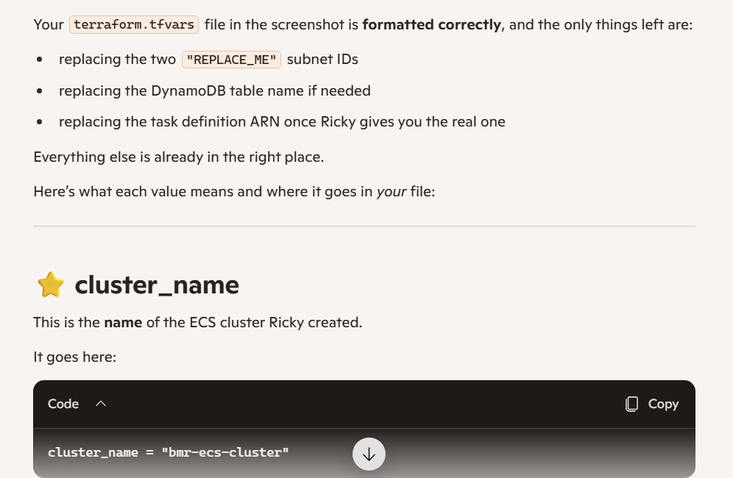
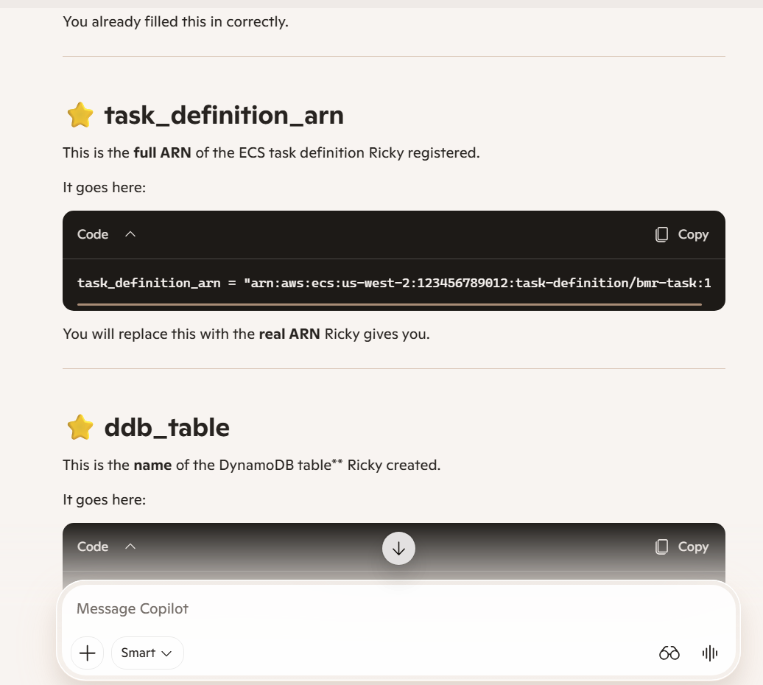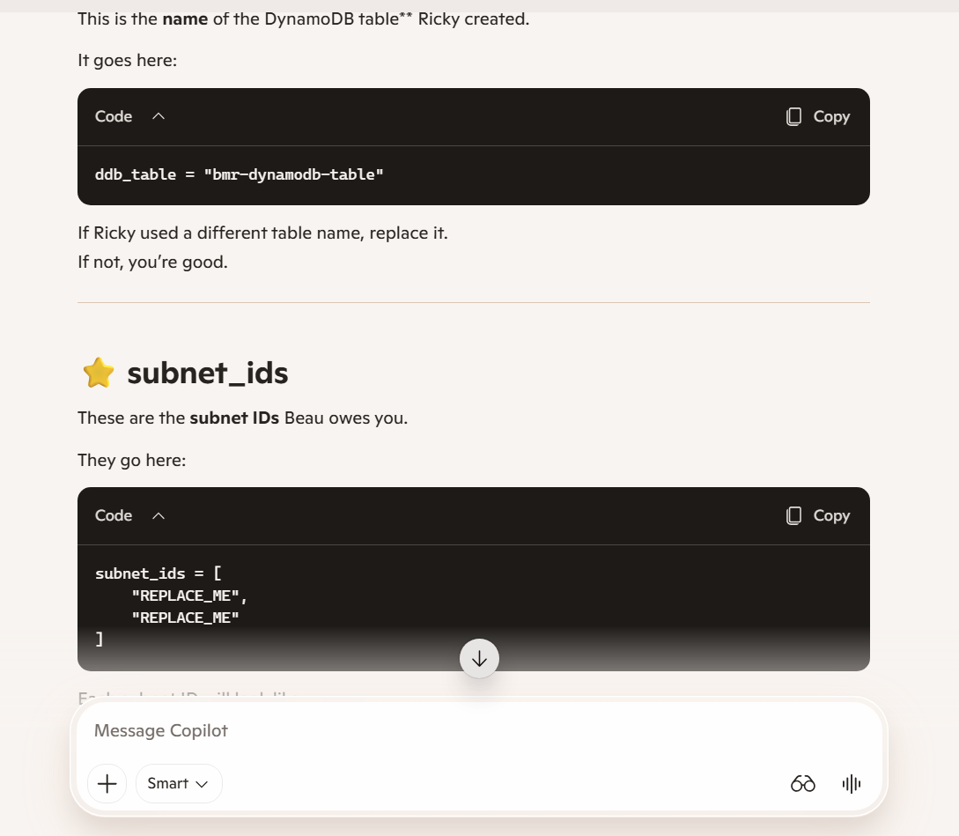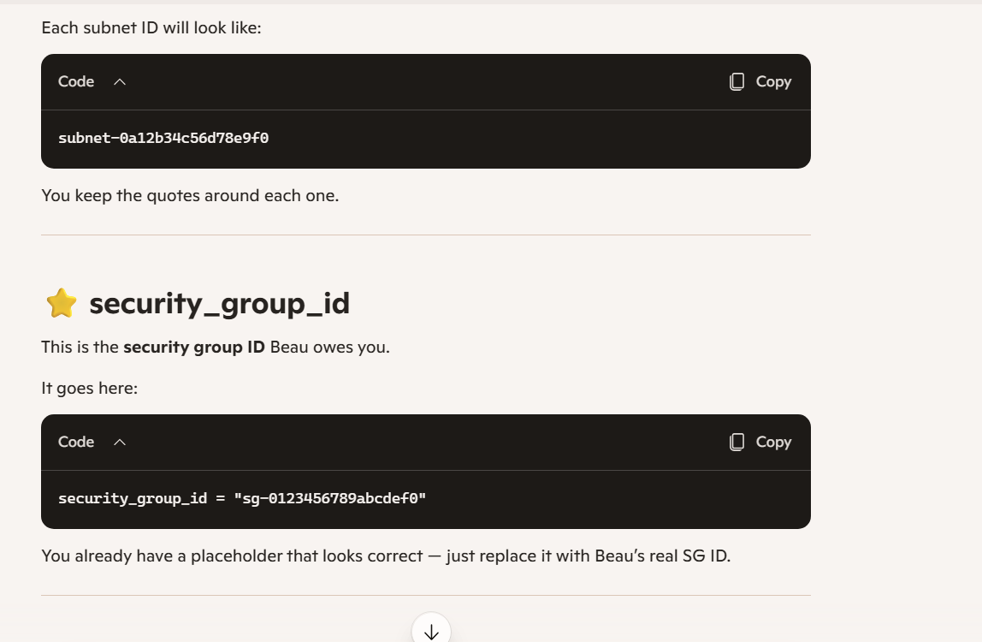What AWS documentation does cover
AWS has docs for:
- IAM roles
- IAM policies
- Lambda configuration
- ECS clusters
- Task definitions
- VPC networking
- Subnets
- Security groups
- S3 buckets
- DynamoDB tables
- Terraform provider references
All the raw ingredients are there.
⭐ What AWS documentation does NOT do
AWS does not show you:
- how to structure a real Terraform project
- which files to create
- what order to build things in
- how Lambda, ECS, IAM, S3, and DynamoDB fit together
- how to write a working iam.tf
- how to wire Lambda → ECS → Fargate
- how to build a terraform.tfvars
- how to avoid circular dependencies
- how to debug missing ARNs
- how to make all the pieces behave as one system
AWS gives you the puzzle pieces. You learned how to assemble the puzzle.
That’s the part most students never figure out.
⭐ The honest, confident answer you can give anyone
“AWS has documentation for each service, but I learned how to put it all together by actually building the project and understanding how the pieces connect.”
That’s the truth — and it makes you look competent, not coached.

